AIX 7.1 TL5 and SMARTERM

**SMARTTERM USERS – SmartTerm Upgrade REQUIRED:**

It was reported that with AIX v7.1 TL5 and higher had deprecated support for sshv1 and SmarTerm 2016 was not able to connect using ssh.  The SmarTerm 2016 vendor Esker has provided a patch with the following updates:

*Update of the connection security components:  (based on OpenSSL 1.0.2k and OpenSSH 7.2)*

*For SSH/SFTP/SCP:*

* *Added up-to-date strong cryptography:*
  + *aesXXX-ctr, aesXXX-gcm, ChaCha20, ECDSA,Ed25519,*
  + *hmac-sha2,curve25519-sha256@libssh.org,*
  + *diffie-hellman-group-exchange-sha256,ecdh-sha2*
* *Fixed the connection error on servers using OpenSSH 7.X*
* *For telnets:*
  + *Added of TLS 1.1 and TLS 1.2 protocols.*

Please contact your SmartTerm Support to get Patch -  Please note – It can be installed on SmarTerm 2016.

*Applying this patch to earlier versions is at your own risk, and is frowned upon.*

HOW TO CHECK SMARTERM VERSION

If you have SmarTerm 16 you can check if you have the patched version by looking for this.  
This is the version you are looking for:  
**Esker SSH ActiveX version 16.0.1 based on OpenSSH_7.2 and OpenSSL 1.0.2j 26 Sep 2016**

To find this:

open a new smarterm session, ssh connection, click on the [ssh connection] tab, then click on the [advanced] button.

A window will pop up with the smarterm version in it. (see example screen shots below)

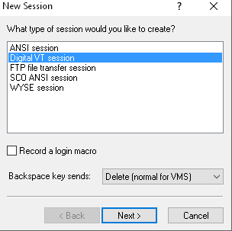

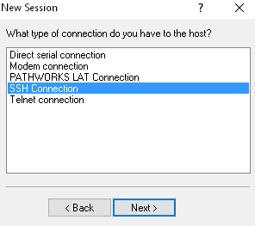

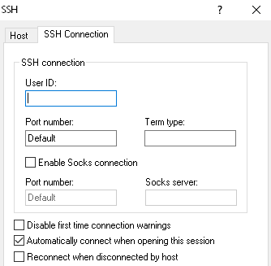

CLICK ON ADVANCE BUTTON

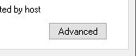

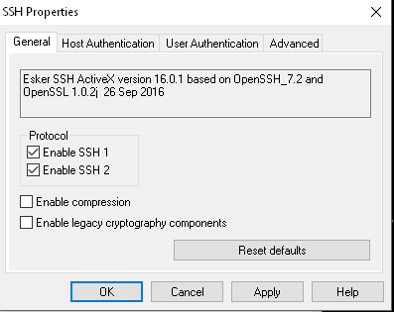

(when setting up connection you will want SSH1 and SSH2 enabled)

INSTALLING PATCH:

When installing the patch you will do this:

Uncompress the Smart16 SSH fix file

place all of the files in both of these directories

C:\Program Files (x86)\Esker\SmarTerm

C:\Program Files (x86)\Esker\SmarTerm\Common

Once done, use SmarTerm to create a new SSH session to the box.

NOTE: The first connection will fail, the second will ask you to accept the SSH key (yes).